

Politechnika Krakowska

Wydział Informatyki i Telekomunikacji

Studia Stacjonarne

 Sprawozdanie z przedmiotu:

**Obliczenia ewaluacyjne**

Temat Projektu:

Implementacja klasycznego algorytmu genetycznego

**Wykonali:**

**Piotr Świebocki**

**Konrad Tatomir**

**Michał Zub**

**Piotr Żywczak**

# Technologie

Do wykonania projektu wykorzystaliśmy język Python i biblioteki tj.:

* tkinter
* matplotlib
* numpy
* time
* benchmark_functions
* opfunu.cec_based.cec2014

# Wymagania środowiska do uruchomienia aplikacji

Do uruchomienia aplikacji należy mieć zainstalowanego pythona i biblioteki:

* tkinter
* matplotlib
* numpy
* time
* benchmark_functions
* opfunu.cec_based.cec2014

Proces instalacji:

git clone <https://github.com/Zubbek/Classic_Genetic_Algorithm.git>

cd [Classic_Genetic_Algorithm](https://github.com/Zubbek/Classic_Genetic_Algorithm.git)

pip install -r requirements.txt

Uruchomienie:

python ./Gui.py

# Wybrane funkcje

* 1. Hypersphere
     1. Zakres poszukiwań [-5, 5]
     2. Wykres

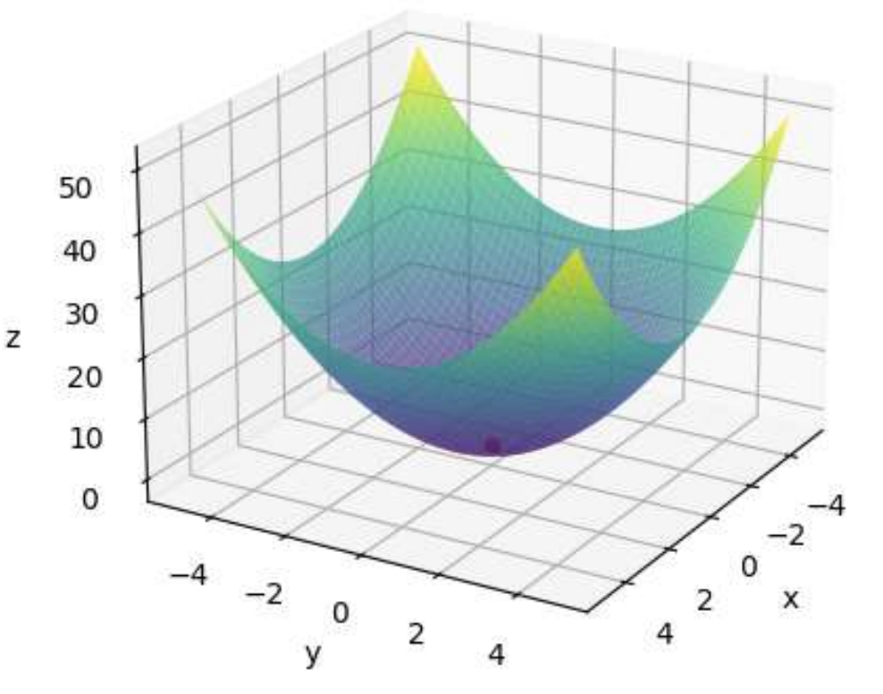

* + 1. Globalne minimum równe 0.0 w punkcie [0.0, 0.0]
    2. Maksimum globalne w punktach [-5.0, -5.0], [5.0,5.0], [-5.0, 5.0], [5.0,-5.0] dla 10 zmiennych to 250
  1. Shifted and Rotated HappyCat Function
     1. Zakres poszukiwań [-50, 50]
     2. Wykres

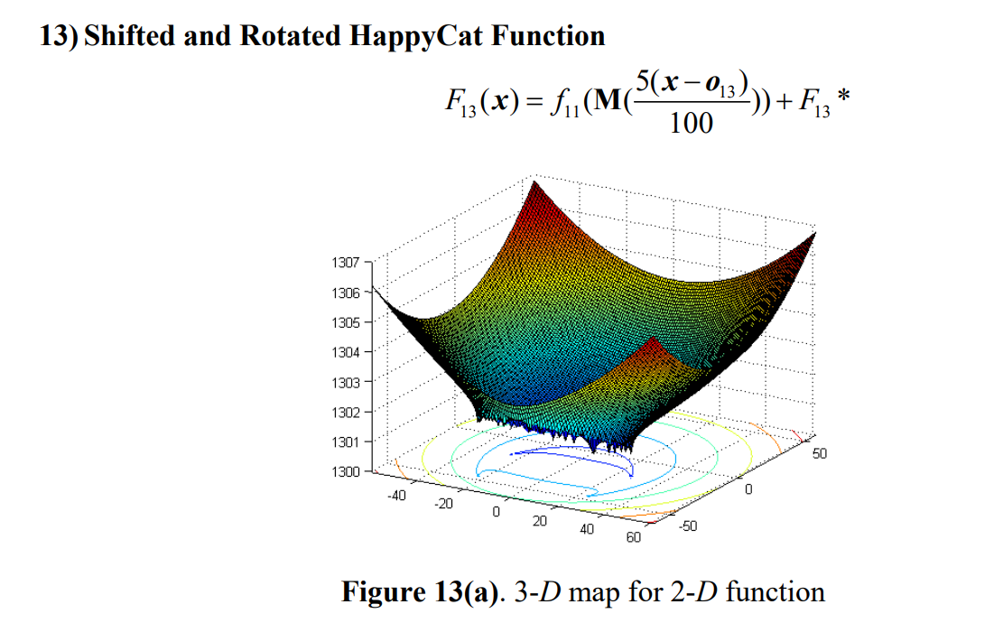

# 4. Testy – Hypersphere

Podstawowa konfiguracja uruchamiania. W testach będzie zmianiane tylko selection method, cross method, i mutation method.

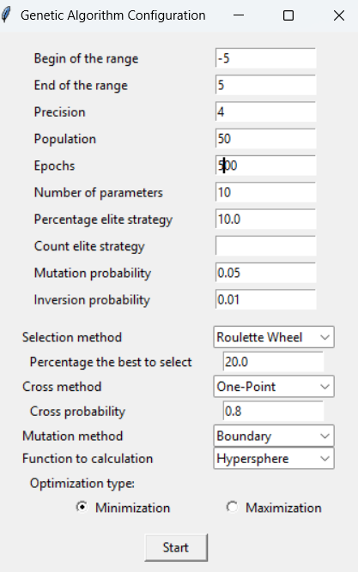

# 4.1. Minimum

Wykresy dla wartości: [ Solution method: Bestsolution, Cross method: Granular crossover, Mutation method: Boundary ]

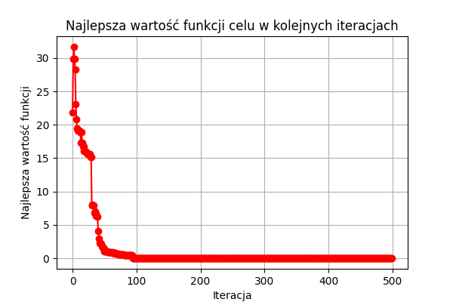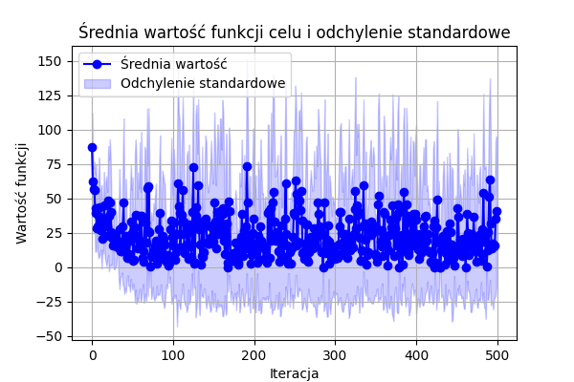

|  |  |  |  |  |  |  |  |  |  |
| --- | --- | --- | --- | --- | --- | --- | --- | --- | --- |
| **Selection Method** | **Cross Method** | **Mutation Method** | **Średni czas** | **Średni Fitness** | **Najlepszy Fitness** | **Najgorszy Fitness** | **Najlepszy czas** | **Najgorszy czas** | **Błąd** |
| Roulette Wheel | One-Point | Boundary | 2,4554 | 0,001322006 | 1,51E-05 | 0,006084328 | 2,4142 | 2,541 | 1,51E-05 |
| Roulette Wheel | One-Point | One-Point | 2,9497 | 0,001253527 | 9,13E-06 | 0,006073896 | 2,6863 | 3,216 | 9,13E-06 |
| Roulette Wheel | One-Point | Two-Point | 3,7723 | 0,000245713 | 6,15E-06 | 0,000855617 | 2,8895 | 5,3441 | 6,15E-06 |
| Roulette Wheel | Two-Point | Boundary | 3,4515 | 2,22E-05 | 2,42E-06 | 5,61E-05 | 3,025 | 4,034 | 2,42E-06 |
| Roulette Wheel | Two-Point | One-Point | 3,346 | 9,80E-05 | 6,15E-06 | 0,000412254 | 3,1371 | 3,6644 | 6,15E-06 |
| Roulette Wheel | Two-Point | Two-Point | 4,2901 | 0,000185281 | 2,42E-06 | 0,001509113 | 3,1756 | 5,6345 | 2,42E-06 |
| Roulette Wheel | Uniform crossover | Boundary | 5,2178 | 0,000148993 | 2,42E-06 | 0,00084146 | 4,1744 | 6,1172 | 2,42E-06 |
| Roulette Wheel | Uniform crossover | One-Point | 5,463 | 8,81E-05 | 3,91E-06 | 0,000373506 | 4,6333 | 6,69 | 3,91E-06 |
| Roulette Wheel | Uniform crossover | Two-Point | 5,3651 | 7,11E-05 | 1,68E-06 | 0,000298246 | 4,299 | 7,2318 | 1,68E-06 |
| Roulette Wheel | Granular crossover | Boundary | 5,5049 | 0,00017932 | 1,68E-06 | 0,001503152 | 3,1001 | 12,0036 | 1,68E-06 |
| Roulette Wheel | Granular crossover | One-Point | 3,3968 | 2,72E-05 | 2,42E-06 | 0,000111959 | 3,0094 | 4,8579 | 2,42E-06 |
| Roulette Wheel | Granular crossover | Two-Point | 3,6959 | 0,000709121 | 3,17E-06 | 0,006060483 | 2,9825 | 6,114 | 3,17E-06 |
| Best solution | One-Point | Boundary | 3,7253 | 0,000118814 | 1,51E-05 | 0,000483788 | 2,9526 | 4,8966 | 1,51E-05 |
| Best solution | One-Point | One-Point | 5,1316 | 0,04280095 | 2,48E-05 | 0,396821844 | 3,6117 | 6,9385 | 2,48E-05 |
| Best solution | One-Point | Two-Point | 4,7303 | 0,003565501 | 9,13E-06 | 0,026227941 | 3,6108 | 5,8502 | 9,13E-06 |
| Best solution | Two-Point | Boundary | 3,5471 | 0,0057008 | 5,40E-06 | 0,056401261 | 3,0876 | 5,0281 | 5,40E-06 |
| Best solution | Two-Point | One-Point | 3,9803 | 0,000230363 | 1,66E-05 | 0,000874991 | 3,3062 | 5,0472 | 1,66E-05 |
| Best solution | Two-Point | Two-Point | 4,026 | 0,001370962 | 4,94E-05 | 0,012281732 | 2,9536 | 5,295 | 4,94E-05 |
| Best solution | Uniform crossover | Boundary | 3,4149 | 0,000283715 | 9,31E-07 | 0,001505387 | 3,0518 | 4,2396 | 9,31E-07 |
| Best solution | Uniform crossover | One-Point | 3,6787 | 0,000741982 | 1,06E-05 | 0,003009843 | 2,958 | 4,9696 | 1,06E-05 |
| Best solution | Uniform crossover | Two-Point | 4,1845 | 0,000679688 | 2,92E-05 | 0,001965144 | 2,9803 | 6,712 | 2,92E-05 |
| Best solution | Granular crossover | Boundary | 3,2443 | 0,004327267 | 3,91E-06 | 0,036869415 | 2,9136 | 3,9695 | 3,91E-06 |
| Best solution | Granular crossover | One-Point | 3,2241 | 0,000716125 | 1,14E-05 | 0,006079857 | 3,0091 | 3,7947 | 1,14E-05 |
| Best solution | Granular crossover | Two-Point | 3,4826 | 0,005306318 | 1,81E-05 | 0,025852386 | 3,1182 | 4,0194 | 1,81E-05 |
| Tournament | One-Point | Boundary | 3,5986 | 0,000854574 | 8,81E-05 | 0,004972566 | 2,5622 | 4,4341 | 8,81E-05 |
| Tournament | One-Point | One-Point | 3,7642 | 0,014753913 | 4,71E-05 | 0,105072904 | 2,6356 | 4,9934 | 4,71E-05 |
| Tournament | One-Point | Two-Point | 3,4946 | 0,017172443 | 0,000107488 | 0,097695184 | 2,922 | 5,2937 | 0,000107488 |
| Tournament | Two-Point | Boundary | 3,762 | 0,001360828 | 2,25E-05 | 0,006187159 | 3,1769 | 4,3953 | 2,25E-05 |
| Tournament | Two-Point | One-Point | 3,8861 | 0,009943231 | 0,000274401 | 0,054824525 | 2,6018 | 5,2857 | 0,000274401 |
| Tournament | Two-Point | Two-Point | 3,5449 | 0,001027672 | 0,000107488 | 0,003518035 | 2,6319 | 4,576 | 0,000107488 |
| Tournament | Uniform crossover | Boundary | 4,404 | 0,001043842 | 1,88E-05 | 0,003816094 | 3,0376 | 5,3293 | 1,88E-05 |
| Tournament | Uniform crossover | One-Point | 5,0917 | 0,001588471 | 7,54E-05 | 0,007602197 | 4,474 | 6,4069 | 7,54E-05 |
| Tournament | Uniform crossover | Two-Point | 5,4887 | 0,002129897 | 2,11E-05 | 0,014178882 | 4,6002 | 7,0292 | 2,11E-05 |
| Tournament | Granular crossover | Boundary | 4,709 | 0,000709196 | 1,66E-05 | 0,003932338 | 3,6041 | 9,4138 | 1,66E-05 |
| Tournament | Granular crossover | One-Point | 3,6443 | 0,001919914 | 0,000102272 | 0,014212413 | 3,0978 | 3,9492 | 0,000102272 |
| Tournament | Granular crossover | Two-Point | 3,8386 | 0,001801062 | 6,20E-05 | 0,006085073 | 3,3882 | 4,2964 | 6,20E-05 |

# 4.2. Maximum

Wykresy dla wartości: [ Solution method: Bestsolution, Cross method: Granular crossover, Mutation method: Boundary ]

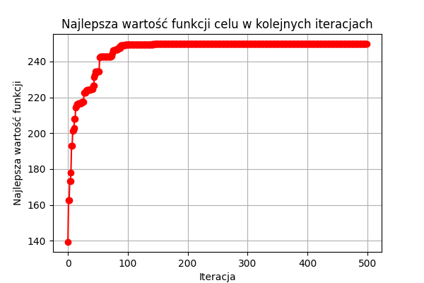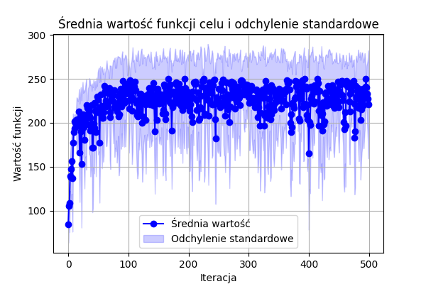

|  |  |  |  |  |  |  |  |  |  |
| --- | --- | --- | --- | --- | --- | --- | --- | --- | --- |
| **Selection Method** | **Cross Method** | **Mutation Method** | **Średni czas** | **Średni Fitness** | **Najgorszy Fitness** | **Najlepszy Fitness** | **Najlepszy czas** | **Najgorszy czas** | **Błąd** |
| Roulette Wheel | One-Point | Boundary | 2,6755 | 249,9927 | 249,9878 | 250 | 2,349 | 3,6227 | 0 |
| Roulette Wheel | One-Point | One-Point | 3,3531 | 249,9957 | 249,9878 | 250 | 2,5824 | 4,1684 | 0 |
| Roulette Wheel | One-Point | Two-Point | 3,897 | 249,9872 | 249,9512 | 250 | 2,8249 | 5,2224 | 0 |
| Roulette Wheel | Two-Point | Boundary | 5,0476 | 249,9945 | 249,9756 | 250 | 3,8867 | 7,0265 | 0 |
| Roulette Wheel | Two-Point | One-Point | 5,8745 | 249,9963 | 249,9878 | 250 | 4,3506 | 12,4403 | 0 |
| Roulette Wheel | Two-Point | Two-Point | 5,5104 | 249,9951 | 249,9756 | 250 | 3,8408 | 7,4499 | 0 |
| Roulette Wheel | Uniform crossover | Boundary | 4,7475 | 249,9902 | 249,9634 | 250 | 3,7975 | 6,9417 | 0 |
| Roulette Wheel | Uniform crossover | One-Point | 3,5741 | 249,9939 | 249,9817 | 250 | 3,1242 | 4,2255 | 0 |
| Roulette Wheel | Uniform crossover | Two-Point | 3,5183 | 249,9927 | 249,9695 | 250 | 3,1407 | 4,0098 | 0 |
| Roulette Wheel | Granular crossover | Boundary | 3,381 | 249,964 | 249,7683 | 250 | 3,0659 | 3,8401 | 0 |
| Roulette Wheel | Granular crossover | One-Point | 3,2064 | 249,9921 | 249,9756 | 250 | 2,872 | 3,7407 | 0 |
| Roulette Wheel | Granular crossover | Two-Point | 3,2725 | 249,9829 | 249,9451 | 250 | 2,9419 | 3,6902 | 0 |
| Best solution | One-Point | Boundary | 3,2026 | 249,7488 | 249,2876 | 249,9268 | 2,8943 | 3,5812 | 0,0732 |
| Best solution | One-Point | One-Point | 3,4663 | 249,6812 | 249,4766 | 249,8719 | 3,1479 | 3,7965 | 0,1281 |
| Best solution | One-Point | Two-Point | 3,9615 | 249,5443 | 248,4591 | 249,8657 | 3,2593 | 4,7395 | 0,1343 |
| Best solution | Two-Point | Boundary | 3,1357 | 249,8165 | 249,5986 | 249,9268 | 2,8989 | 3,4936 | 0,0732 |
| Best solution | Two-Point | One-Point | 3,6466 | 249,7817 | 249,5857 | 249,8597 | 3,269 | 4,0782 | 0,1403 |
| Best solution | Two-Point | Two-Point | 4,9902 | 249,7958 | 249,5681 | 249,9756 | 3,6015 | 6,1337 | 0,0244 |
| Best solution | Uniform crossover | Boundary | 5,0762 | 249,8671 | 249,555 | 249,9817 | 3,5156 | 8,638 | 0,0183 |
| Best solution | Uniform crossover | One-Point | 3,8426 | 249,7707 | 249,4515 | 249,9695 | 3,3126 | 5,1236 | 0,0305 |
| Best solution | Uniform crossover | Two-Point | 3,2589 | 249,7818 | 249,4278 | 249,939 | 3,0467 | 3,4536 | 0,061 |
| Best solution | Granular crossover | Boundary | 3,1515 | 249,858 | 249,4218 | 249,9695 | 2,9438 | 3,3931 | 0,0305 |
| Best solution | Granular crossover | One-Point | 3,1973 | 249,6228 | 249,1698 | 249,9329 | 2,8557 | 3,4867 | 0,0671 |
| Best solution | Granular crossover | Two-Point | 3,3487 | 249,7353 | 249,1027 | 249,9268 | 3,0861 | 3,6223 | 0,0732 |
| Tournament | One-Point | Boundary | 3,6878 | 249,4943 | 248,6556 | 249,8657 | 3,1947 | 7,0085 | 0,1343 |
| Tournament | One-Point | One-Point | 4,4725 | 249,4597 | 248,9114 | 249,8109 | 3,2505 | 7,5456 | 0,1891 |
| Tournament | One-Point | Two-Point | 3,8676 | 249,3425 | 248,6789 | 249,7255 | 3,1673 | 4,2611 | 0,2745 |
| Tournament | Two-Point | Boundary | 3,622 | 249,487 | 248,6647 | 249,9329 | 2,6116 | 4,8175 | 0,0671 |
| Tournament | Two-Point | One-Point | 3,5625 | 249,4765 | 248,7007 | 249,8414 | 3,2519 | 3,812 | 0,1586 |
| Tournament | Two-Point | Two-Point | 3,5895 | 249,5163 | 248,7677 | 249,8658 | 3,2723 | 4,123 | 0,1342 |
| Tournament | Uniform crossover | Boundary | 3,962 | 249,7795 | 249,2089 | 249,939 | 3,4554 | 5,7174 | 0,061 |
| Tournament | Uniform crossover | One-Point | 4,2915 | 249,4751 | 248,5613 | 249,9451 | 3,3353 | 5,8563 | 0,0549 |
| Tournament | Uniform crossover | Two-Point | 3,715 | 249,6457 | 249,0844 | 249,9024 | 3,2993 | 5,1525 | 0,0976 |
| Tournament | Granular crossover | Boundary | 3,6738 | 249,7281 | 249,4638 | 249,8963 | 3,0254 | 4,978 | 0,1037 |
| Tournament | Granular crossover | One-Point | 4,2596 | 249,667 | 249,4574 | 249,8719 | 3,1973 | 5,7794 | 0,1281 |
| Tournament | Granular crossover | Two-Point | 3,6042 | 249,4417 | 248,7013 | 249,8658 | 3,253 | 4,1657 | 0,1342 |

# 5. Testy – Shifted and Rotated HappyCat Function

Podstawowa konfiguracja uruchamiania. W testach będzie zmieniane tylko selection method, cross method, i mutation method.

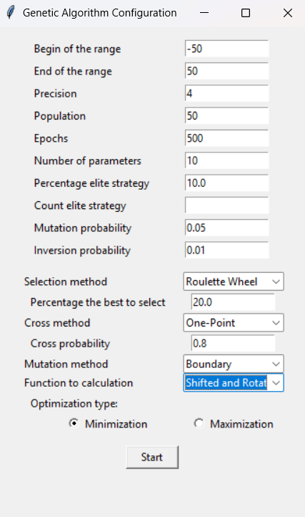

# 5.1. Minimum

Wykresy dla wartości: [ Solution method: Bestsolution, Cross method: Granular crossover, Mutation method: Boundary ]

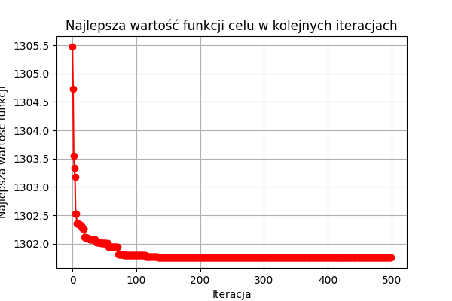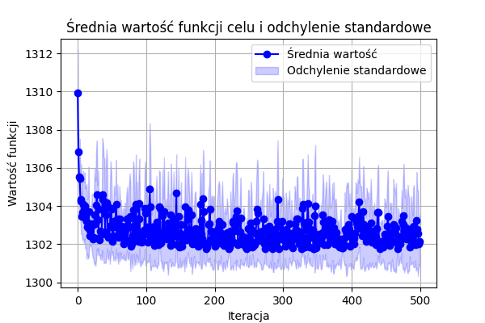

|  |  |  |  |  |  |  |  |  |
| --- | --- | --- | --- | --- | --- | --- | --- | --- |
| **Selection Method** | **Cross Method** | **Mutation Method** | **Średni czas** | **Średni Fitness** | **Najlepszy Fitness** | **Najgorszy Fitness** | **Najlepszy czas** | **Najgorszy czas** |
| Roulette Wheel | One-Point | Boundary | 5,0493 | 1301,7959 | 1301,7586 | 1301,9291 | 4,8123 | 5,5757 |
| Roulette Wheel | One-Point | One-Point | 5,9589 | 1301,7781 | 1301,7601 | 1301,902 | 4,9333 | 8,1777 |
| Roulette Wheel | One-Point | Two-Point | 5,0446 | 1301,785 | 1301,7594 | 1301,9148 | 4,8777 | 5,2896 |
| Roulette Wheel | Two-Point | Boundary | 5,0558 | 1301,7674 | 1301,7589 | 1301,7927 | 5,0219 | 5,1064 |
| Roulette Wheel | Two-Point | One-Point | 5,0662 | 1301,7666 | 1301,7585 | 1301,7812 | 5,0272 | 5,1348 |
| Roulette Wheel | Two-Point | Two-Point | 5,0957 | 1301,8122 | 1301,7639 | 1301,9531 | 5,0169 | 5,1703 |
| Roulette Wheel | Uniform crossover | Boundary | 5,3743 | 1301,8628 | 1301,7728 | 1302,1392 | 5,2028 | 5,5564 |
| Roulette Wheel | Uniform crossover | One-Point | 5,8216 | 1301,7688 | 1301,7584 | 1301,788 | 5,3101 | 6,9685 |
| Roulette Wheel | Uniform crossover | Two-Point | 5,4924 | 1301,7864 | 1301,7584 | 1301,9537 | 5,2997 | 5,6807 |
| Roulette Wheel | Granular crossover | Boundary | 5,5087 | 1302,5013 | 1301,9124 | 1303,9844 | 5,226 | 6,9401 |
| Roulette Wheel | Granular crossover | One-Point | 5,3319 | 1301,7812 | 1301,7593 | 1301,8987 | 5,2536 | 5,4286 |
| Roulette Wheel | Granular crossover | Two-Point | 5,2666 | 1301,8042 | 1301,7592 | 1301,8958 | 5,1693 | 5,3944 |
| Best solution | One-Point | Boundary | 4,9177 | 1301,7611 | 1301,7583 | 1301,772 | 4,8167 | 5,0639 |
| Best solution | One-Point | One-Point | 5,0587 | 1301,7769 | 1301,7584 | 1301,8934 | 4,9343 | 5,4264 |
| Best solution | One-Point | Two-Point | 4,9834 | 1301,764 | 1301,7587 | 1301,7789 | 4,8835 | 5,1943 |
| Best solution | Two-Point | Boundary | 5,6341 | 1301,7787 | 1301,7583 | 1301,8977 | 5,0625 | 7,9235 |
| Best solution | Two-Point | One-Point | 5,206 | 1301,7789 | 1301,7583 | 1301,9095 | 5,1226 | 5,3772 |
| Best solution | Two-Point | Two-Point | 5,2584 | 1301,7955 | 1301,7583 | 1301,9536 | 5,0041 | 5,9267 |
| Best solution | Uniform crossover | Boundary | 5,3255 | 1301,7629 | 1301,7583 | 1301,7861 | 5,1701 | 5,5436 |
| Best solution | Uniform crossover | One-Point | 5,2743 | 1301,7632 | 1301,7583 | 1301,7789 | 5,1876 | 5,3681 |
| Best solution | Uniform crossover | Two-Point | 5,2986 | 1301,7635 | 1301,7583 | 1301,7762 | 5,2069 | 5,4632 |
| Best solution | Granular crossover | Boundary | 5,3256 | 1301,7673 | 1301,7588 | 1301,7877 | 5,1021 | 5,8877 |
| Best solution | Granular crossover | One-Point | 5,3264 | 1301,7613 | 1301,7584 | 1301,7651 | 5,2442 | 5,4119 |
| Best solution | Granular crossover | Two-Point | 5,2977 | 1301,7653 | 1301,7585 | 1301,7791 | 5,2118 | 5,5775 |
| Tournament | One-Point | Boundary | 5,2352 | 1301,7634 | 1301,7584 | 1301,7761 | 5,1508 | 5,3024 |
| Tournament | One-Point | One-Point | 5,2147 | 1301,7622 | 1301,7584 | 1301,7699 | 5,1523 | 5,2672 |
| Tournament | One-Point | Two-Point | 5,2645 | 1301,7635 | 1301,7583 | 1301,7799 | 5,1566 | 5,5139 |
| Tournament | Two-Point | Boundary | 5,309 | 1301,7931 | 1301,7584 | 1301,8974 | 5,2663 | 5,4041 |
| Tournament | Two-Point | One-Point | 5,3379 | 1301,7765 | 1301,7583 | 1301,9067 | 5,2268 | 5,597 |
| Tournament | Two-Point | Two-Point | 5,2967 | 1301,7651 | 1301,7583 | 1301,7789 | 5,1809 | 5,6238 |
| Tournament | Uniform crossover | Boundary | 5,5658 | 1301,7634 | 1301,7583 | 1301,7826 | 5,5123 | 5,6514 |
| Tournament | Uniform crossover | One-Point | 5,611 | 1301,7755 | 1301,7583 | 1301,8968 | 5,5358 | 5,709 |
| Tournament | Uniform crossover | Two-Point | 5,5519 | 1301,7687 | 1301,7583 | 1301,7791 | 5,4771 | 5,6348 |
| Tournament | Granular crossover | Boundary | 5,5568 | 1301,7694 | 1301,7584 | 1301,8274 | 5,4042 | 5,9423 |
| Tournament | Granular crossover | One-Point | 5,5927 | 1301,7753 | 1301,7583 | 1301,8756 | 5,5004 | 5,8384 |
| Tournament | Granular crossover | Two-Point | 5,573 | 1301,7607 | 1301,7583 | 1301,7766 | 5,513 | 5,6821 |

# 5.2. Maximum

Wykresy dla wartości: [ Solution method: Bestsolution, Cross method: Granular crossover, Mutation method: Boundary ]

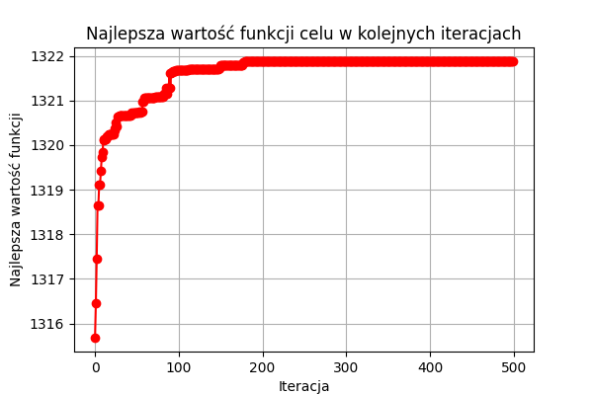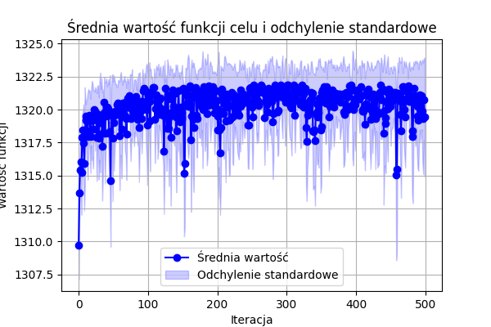

|  |  |  |  |  |  |  |  |  |
| --- | --- | --- | --- | --- | --- | --- | --- | --- |
| **Metoda Selekcji** | **Metoda Krzyżowania** | **Metoda Mutacji** | **Średni czas** | **Średni Fitness** | **Najgorszy Fitness** | **Najlepszy Fitness** | **Najlepszy czas** | **Najgorszy czas** |
| Roulette Wheel | One-Point | Boundary | 5,9352 | 1321,6675 | 1321,2691 | 1321,8765 | 4,9944 | 8,0372 |
| Roulette Wheel | One-Point | One-Point | 5,6837 | 1321,6897 | 1321,2032 | 1321,9057 | 4,8623 | 8,331 |
| Roulette Wheel | One-Point | Two-Point | 5,8659 | 1321,8216 | 1321,2964 | 1321,907 | 5,3772 | 7,935 |
| Roulette Wheel | Two-Point | Boundary | 8,1555 | 1321,6547 | 1321,1913 | 1321,9061 | 5,545 | 8,7346 |
| Roulette Wheel | Two-Point | One-Point | 9,0727 | 1321,615 | 1320,9584 | 1321,9116 | 8,4996 | 9,6193 |
| Roulette Wheel | Two-Point | Two-Point | 6,3416 | 1321,7815 | 1321,4961 | 1321,9085 | 5,1073 | 9,2312 |
| Roulette Wheel | Uniform crossover | Boundary | 8,2513 | 1321,4366 | 1319,7204 | 1321,8769 | 7,7591 | 9,0588 |
| Roulette Wheel | Uniform crossover | One-Point | 8,064 | 1321,7458 | 1320,9164 | 1321,911 | 7,6849 | 8,5104 |
| Roulette Wheel | Uniform crossover | Two-Point | 8,1251 | 1321,7905 | 1321,5807 | 1321,9078 | 7,8168 | 9,0332 |
| Roulette Wheel | Granular crossover | Boundary | 7,9059 | 1320,7692 | 1319,9573 | 1321,4254 | 7,7395 | 8,1263 |
| Roulette Wheel | Granular crossover | One-Point | 7,7623 | 1321,769 | 1321,3937 | 1321,9036 | 7,1062 | 8,1 |
| Roulette Wheel | Granular crossover | Two-Point | 7,7988 | 1321,7163 | 1321,4876 | 1321,9099 | 7,374 | 8,4878 |
| Best solution | One-Point | Boundary | 7,4261 | 1321,7659 | 1321,2679 | 1321,9121 | 6,975 | 7,7285 |
| Best solution | One-Point | One-Point | 7,1298 | 1321,8619 | 1321,6137 | 1321,9121 | 4,9669 | 8,0564 |
| Best solution | One-Point | Two-Point | 5,5916 | 1321,7664 | 1321,5807 | 1321,912 | 4,8927 | 7,4831 |
| Best solution | Two-Point | Boundary | 7,6197 | 1321,7782 | 1321,0474 | 1321,9121 | 7,3943 | 7,8452 |
| Best solution | Two-Point | One-Point | 7,7628 | 1321,7 | 1321,172 | 1321,9121 | 7,3695 | 8,7607 |
| Best solution | Two-Point | Two-Point | 6,2316 | 1321,5235 | 1321,0136 | 1321,8658 | 4,9684 | 8,5786 |
| Best solution | Uniform crossover | Boundary | 7,5022 | 1321,8111 | 1321,4643 | 1321,9121 | 5,1943 | 8,5036 |
| Best solution | Uniform crossover | One-Point | 8,1674 | 1321,8224 | 1321,6275 | 1321,9121 | 7,7274 | 9,0956 |
| Best solution | Uniform crossover | Two-Point | 7,6288 | 1321,8388 | 1321,6139 | 1321,8809 | 5,1046 | 9,1351 |
| Best solution | Granular crossover | Boundary | 5,2917 | 1321,8232 | 1321,2867 | 1321,9121 | 4,9855 | 6,3006 |
| Best solution | Granular crossover | One-Point | 7,5927 | 1321,8512 | 1321,6604 | 1321,9121 | 6,2326 | 8,1473 |
| Best solution | Granular crossover | Two-Point | 8,1336 | 1321,8259 | 1321,5809 | 1321,9121 | 7,6634 | 9,0211 |
| Tournament | One-Point | Boundary | 7,5178 | 1321,8738 | 1321,8334 | 1321,9121 | 5,2492 | 9,5259 |
| Tournament | One-Point | One-Point | 7,7727 | 1321,8611 | 1321,5827 | 1321,9113 | 6,4175 | 8,1519 |
| Tournament | One-Point | Two-Point | 6,7361 | 1321,8344 | 1321,6268 | 1321,9119 | 4,9122 | 8,5882 |
| Tournament | Two-Point | Boundary | 5,1903 | 1321,6886 | 1321,172 | 1321,9113 | 5,0814 | 5,3891 |
| Tournament | Two-Point | One-Point | 5,4019 | 1321,7775 | 1321,1636 | 1321,9121 | 5,2692 | 5,5534 |
| Tournament | Two-Point | Two-Point | 7,1158 | 1321,8034 | 1321,221 | 1321,9121 | 5,3458 | 8,8029 |
| Tournament | Uniform crossover | Boundary | 5,8853 | 1321,7678 | 1321,6139 | 1321,912 | 5,2764 | 8,4877 |
| Tournament | Uniform crossover | One-Point | 5,6157 | 1321,8276 | 1321,5808 | 1321,9121 | 5,3409 | 5,8815 |
| Tournament | Uniform crossover | Two-Point | 5,6252 | 1321,7662 | 1321,2212 | 1321,9121 | 5,5061 | 5,7178 |
| Tournament | Granular crossover | Boundary | 5,7046 | 1321,7281 | 1321,2213 | 1321,9121 | 5,6106 | 6,1617 |
| Tournament | Granular crossover | One-Point | 5,8054 | 1321,8584 | 1321,5805 | 1321,9121 | 5,4922 | 6,3697 |
| Tournament | Granular crossover | Two-Point | 5,8065 | 1321,8164 | 1321,5808 | 1321,9121 | 5,6746 | 6,0852 |

# 6. Podsumowanie

W zrealizowanym projekcie wszystkie wyniki obliczane wyniki są bardzo zbliżone do właściwych. Różnice pomiędzy poszczególnymi konfiguracjami metod mutacji, selecji i krosowania występują, ale nie są one duże w przewidywanych wynikach.